Project One

**SQL**  
The closest city for me in the list is Cairo, Egypt. Was honestly hoping to find Giza, but let’s face it, that’s one bridge away from Cairo.

select * from city_data where city ='Cairo'  
select * from global_data

**Moving Average.**

I am not sure, do I copy paste the result? I did do the moving average, I decided to ignore the first half century in the global data because Cairo only starts at 1808, and I took the moving average of 3 and 5 years, that’s how it looks for 5. It goes on until 2013, the last recorded Cairo data.

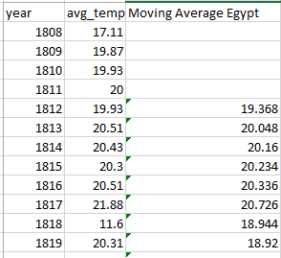 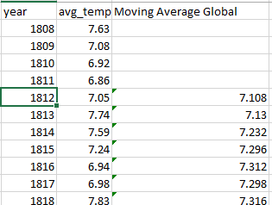

**Line Chart.**

**Observation.**

Since the 3 years average is a bit clearer, I will refer to it from now on.

1. The temperature in both line are increasing, the changes from a few hundred years however are minimal, only two degrees.
2. The consistency of the increase in both Cairo and the World show that Cairo is susceptible to global changes, there are small drops every now and then, some inconsistencies between certain years, but overall the same trend, global warming.
3. Considering that the ice is melting in the poles, these two degrees do make a difference.
4. The degrees peaked during the worst years of conflict (like WW1 and WW2), but then decreased a bit, but never to the original state, that would indicate that the automation and mobilization at those times lead to extremely high fuel usage, and the follow up destruction causes worsening global conditions for the next years.